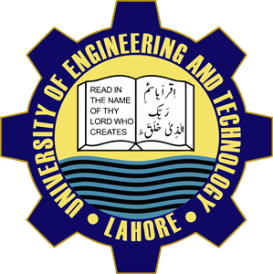University of Engineering and Technology

***My First Day at University***

I was very excited at first day of my university. Because I have chosen best engineering university of Pakistan. A night before the first day, I prepared my clothes and other accessories. Next day, when I entered UET, I came across a new world. It was the orientation day. I went to my Computer Engineering department but we were asked to visit the university till 10 am then to reach the auditorium. I visited the university.

Senior students were ragging the new ones. Some seniors also tried to rag me but I was careful so I did not allow them to tease me. After visiting the UET, I went to auditorium. After some wait, orientation ceremony began. We were oriented about university, its curriculum, its rules and regulations. Ceremony continued for three hours. After that, we were visited university by bus. Then, I returned home. It was a good day.

Name:Muhammad Furqan

Roll No. : 2022-R/2021-CS-199

Semester : 1st